NAME: Rosemary Agbozo

EMAIL: rosemary.agbozo@womentechster.org

PRACTICAL ACTIVITY 4

**Write a shell script to validate password strength when a user enters. Here are a few assumptions for the password string.**

* Length – minimum of 8 characters.
* Contain both alphabet and number.
* Include both the small and capital case letters.

If the password doesn’t comply with any of the above conditions, then the script should report it as a <Weak Password> if the password complies with the conditions, it should echo <Strong Password Secure User>

**ANSWER**

1. I created an auntentic.sh script per the question to enter my code. I used nano editor. Before that, I add execute to the permission of the script for all. Below is a picture of the commands used.

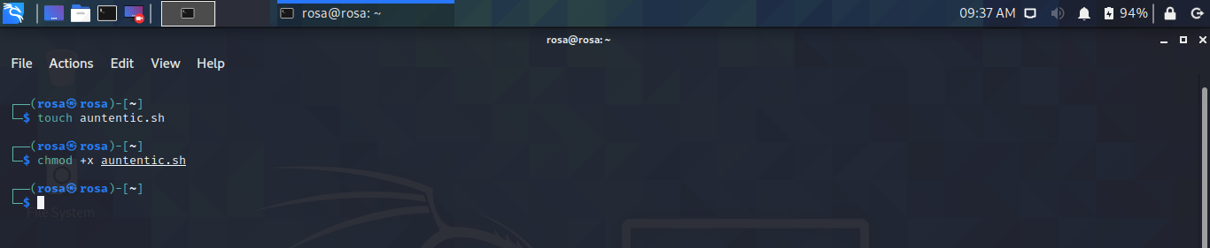

1. I typed out my code per the criteria of the question. I added a special character detection. Such that the password much have a special character before it is accepted as a strong password. Below is a picture of the code and also a copy of the code in text.

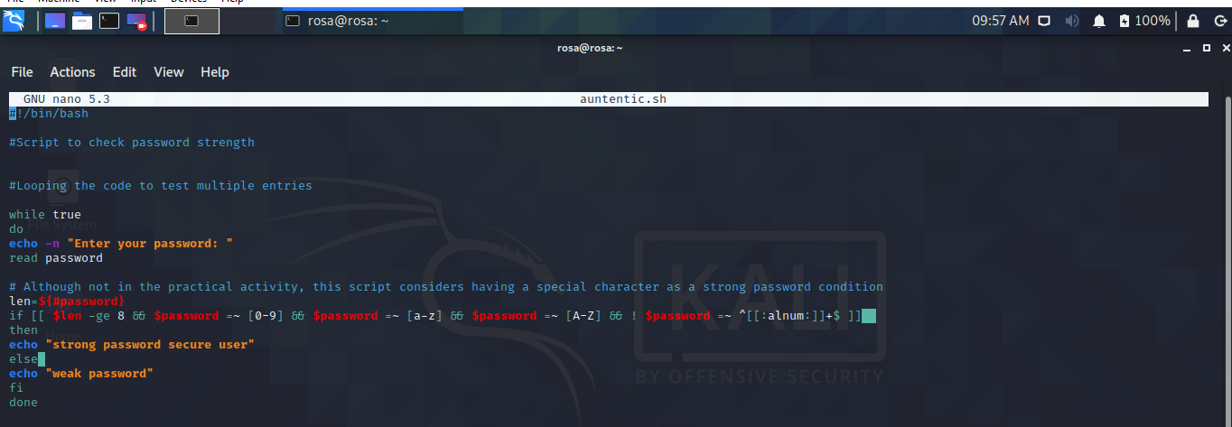

**SCRIPT – auntentic.sh in nano**

#!/bin/bash

#Script to check password strength

#Looping the code to test multiple entries

while true

do

echo -n "Enter your password: "

read password

# Although not in the practical activity, this script considers having a special character as a strong password condition

len=${#password}

if [[ $len -ge 8 && $password =~ [0-9] && $password =~ [a-z] && $password =~ [A-Z] && ! $password =~ ^[[:alnum:]]+$ ]]

then

echo "strong password secure user"

else

echo "weak password"

fi

done

1. Testing various passwords to see the outcome. Screen shots of output will be attached down below.

